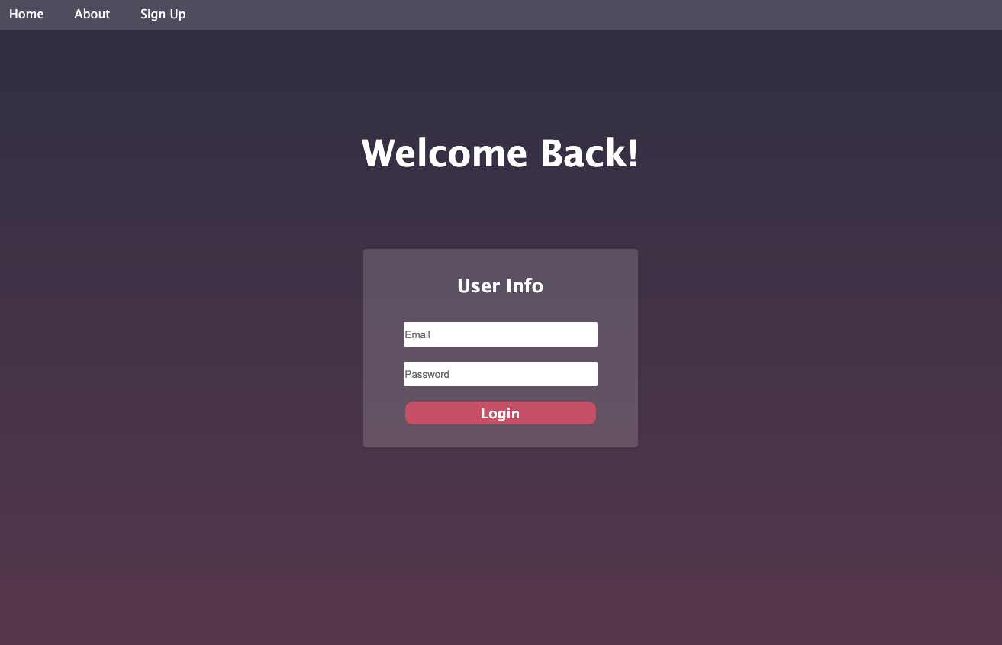

Login Challenge -index.html

<!DOCTYPE html>

<html lang="en">

<head>

<meta charset="UTF-8" />

<meta name="viewport" content="width=device-width, initial-scale=1.0" />

<title>Login Page Challenge</title>

<link rel="stylesheet" href="style.css" />

</head>

<body>

<nav id="navbar">

<p class="nav-item">Home</p>

<p class="nav-item">About</p>

<p class="nav-item">Sign Up</p>

</nav>

​

<div id="login">

<h1>Welcome Back!</h1>

<div id="login-bg">

<h3>User Info</h3>

<input type="text" placeholder="Email" />

<input type="password" placeholder="Password" />

<button>Login</button>

</div>

</div>

</body>

</html>

Login Challenge - style.css

body {

background: linear-gradient(

0deg,

rgb(128, 71, 94, 1) 0%,

rgba(52, 52, 74, 1) 100%

);

height: 100vh;

margin: 0;

}

#navbar {

display: flex;

flex-direction: row;

height: 40px;

width: 100vw;

background-color: rgba(255, 255, 255, 0.15);

}

.nav-item {

color: white;

font-family: "Lucida Sans", "Lucida Sans Regular", "Lucida Grande",

"Lucida Sans Unicode", Geneva, Verdana, sans-serif;

margin: 10px 20px;

}

#login {

text-align: center;

display: flex;

align-items: center;

flex-direction: column;

}

h1 {

color: white;

margin: 8%;

font-family: "Lucida Sans", "Lucida Sans Regular", "Lucida Grande",

"Lucida Sans Unicode", Geneva, Verdana, sans-serif;

font-size: 3em;

}

h3 {

font-family: "Lucida Sans", "Lucida Sans Regular", "Lucida Grande",

"Lucida Sans Unicode", Geneva, Verdana, sans-serif;

color: white;

font-size: 1.5em;

}

#login-bg {

display: flex;

flex-direction: column;

align-items: center;

background-color: rgba(255, 255, 255, 0.15);

width: 300px;

padding: 10px 30px 30px 30px;

border-radius: 5px;

}

input {

margin: 10px;

border-radius: 2px;

border: none;

height: 30px;

width: 250px;

}

button {

background-color: rgba(204, 90, 113, 1);

color: white;

border: none;

height: 30px;

width: 250px;

font-family: "Lucida Sans", "Lucida Sans Regular", "Lucida Grande",

"Lucida Sans Unicode", Geneva, Verdana, sans-serif;

font-size: large;

font-weight: bolder;

border-radius: 10px;

margin-top: 10px;

}